TiAL 35mm WG “reclocking” procedure for use with the FM3 turbo system
Lee Bohon 7/12/01

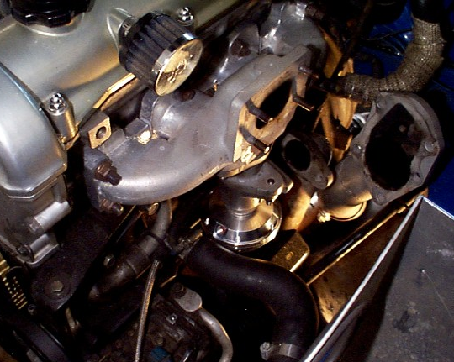

Above is a BEFORE RECLOCKING shot showing where the air fitting hole points (at an angle) towards the radiator hose. The with the air fitting in place, it interferes with the hose and therefore a reclocking is required to make the WG fit.

1) Position the WG with the exhaust inlet face down on a work bench

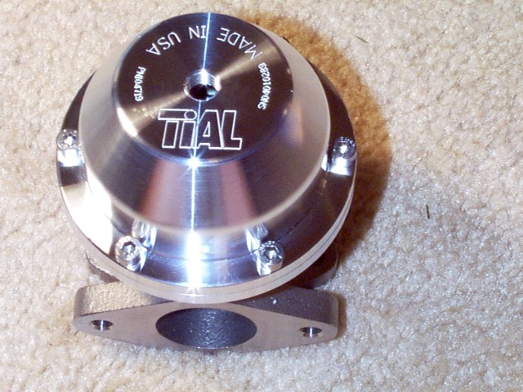

2) Carefully remove the 6 allen head (4mm??) screws in a diagonal/progressive nature. Keep in mind that while you remove these screws, the main housing will want to pop upward as these screws are holding the spring compressed. This is a good job for two people: one to push down on the main housing while the other person loosens the screws; or if you have a press (such as a drill press) you can have that hold the load. If you have neither, you can do it by yourself; I did.

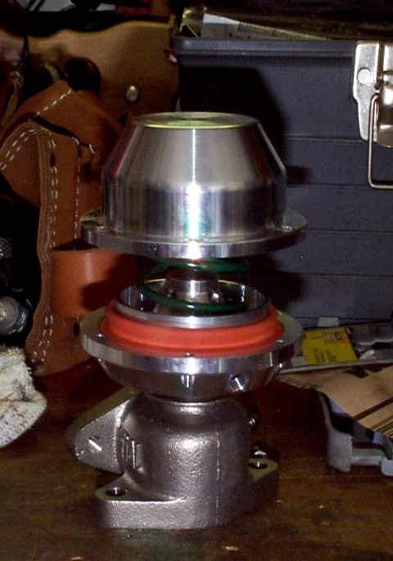

3) Lift the main housing off the WG (it will be pushed up by the spring underneath once you get the screws off in step 2).

4) Lift the spring out and set aside.

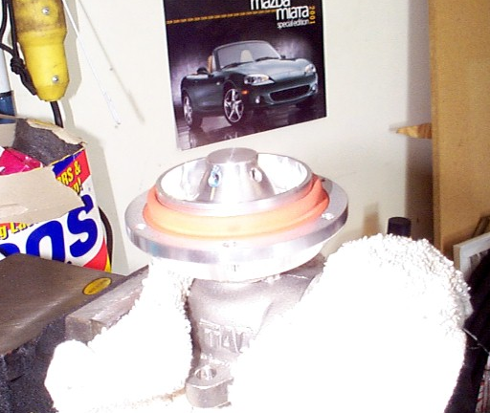

5) Loosen the 4 allen screws (2mm??) on the spring perch / diaphragm mount. Once the screws are out, the WG valve will drop out of the exhaust inlet side. Set it aside with the spring, main housing, and the spring perch / diaphragm mount that also just came free.

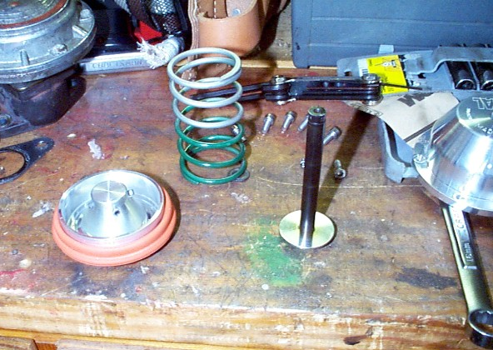

6) Loosen the 2mm allen set screw on the lock nut.

7) Loosen this lock nut (no need to remove it). I think it required a 14 or 17mm deep well.

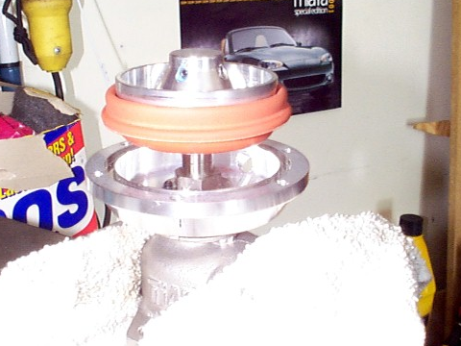
(This image still shows the diaphragm mount/spring perch already removed. This was the only picture I remembered to take which showed the locknut underneath the mount/perch.)

8) Rotate the upper housing counter clock wise about 90 degrees (doesn’t have to be perfect) and lock it back in place by tightening the lock nut. Tighten the setscrew to lock the lock nut in place.

9) Slide the WG valve back in place. Place the spring perch/diaphragm back on the end of the valve “stem” and tighten the 4 setscrews.

10) Let the perch/mount rest all the way down so that you can re-seat the orange diaphragm back into the recess on the upper housing.

11) Place the spring back in place.

12) Place the main housing on top of the extended spring.

13) Carefully push down on the main housing to compress the spring. IMPORTANT! : Make sure that when the main housing seats itself to the upper housing, that no part of the diaphragm is pinched. It went really easy for me with no press or second person, but just keep an eye on this.

14) Tighten the 6 screws that hold the main housing in place and you’re ready to continue with the turbo install. The pic below shows the WG air fitting hole now pointing towards the drivers side, away from the radiator hose.

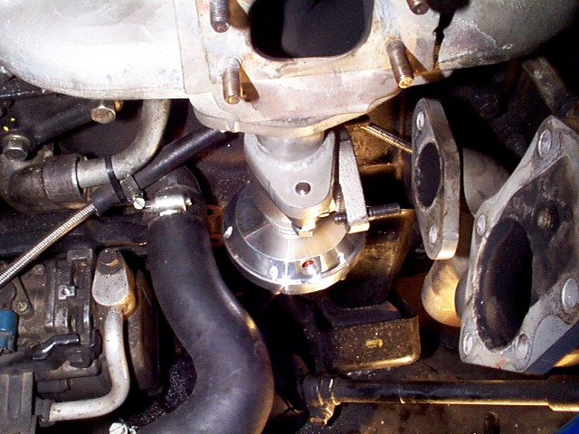

Note: One install hint. I found the easiest way to re-install everything is to mount the WG to the “WG to Exh. Manifold adapter” first, then mount that assembly to the exhaust manifold. There is a motor mount bolt that comes within a few millimeters from the WG body and makes it difficult to install unless done in this order.

While I’m on install hints, I’ve found that at this point, it’s easiest to go ahead and mount the WG dump pipe (of the down pipe) to the WG now while there is easy access to the studs/nuts. Next, slip the turbo onto the main down pipe flange, then slip the turbo onto the exhaust manifold. Tighten up the nuts and go from there.

